Tutorial

- How to install Spyder
- How to install and set Rule Binder
- How to install and set Eclipse
- Download the newest eclipse from eclipse.org
- Open the execute file
- Install PyDev
Help → Eclipse Marketplace → search pydev → choose 2nd pydev that appears → install
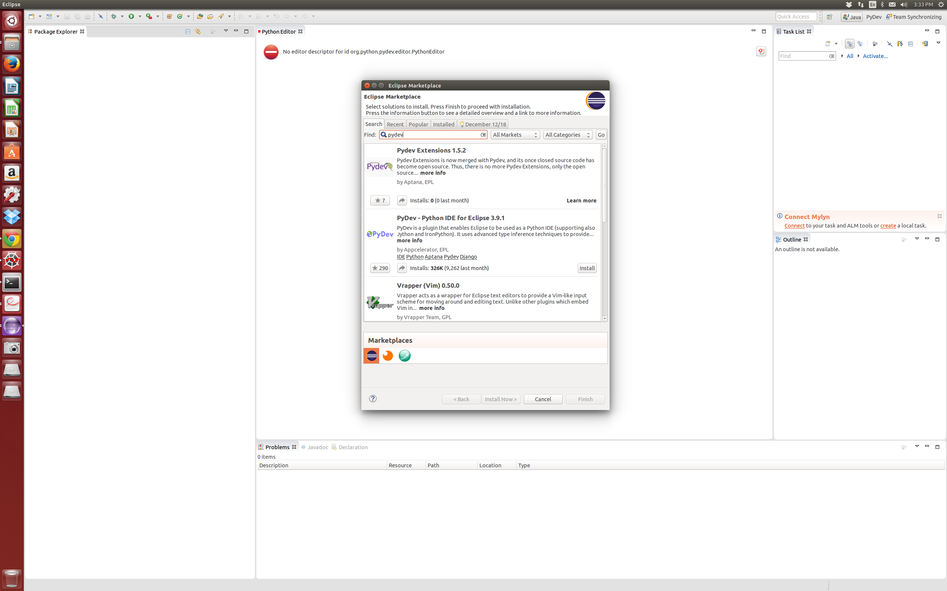

- Adding project with github
(example: adding pysb) github.com(pysb) → copy url → eclipse gui → right click everywhere → import → Git folder (...project) → clone URL → … → finish
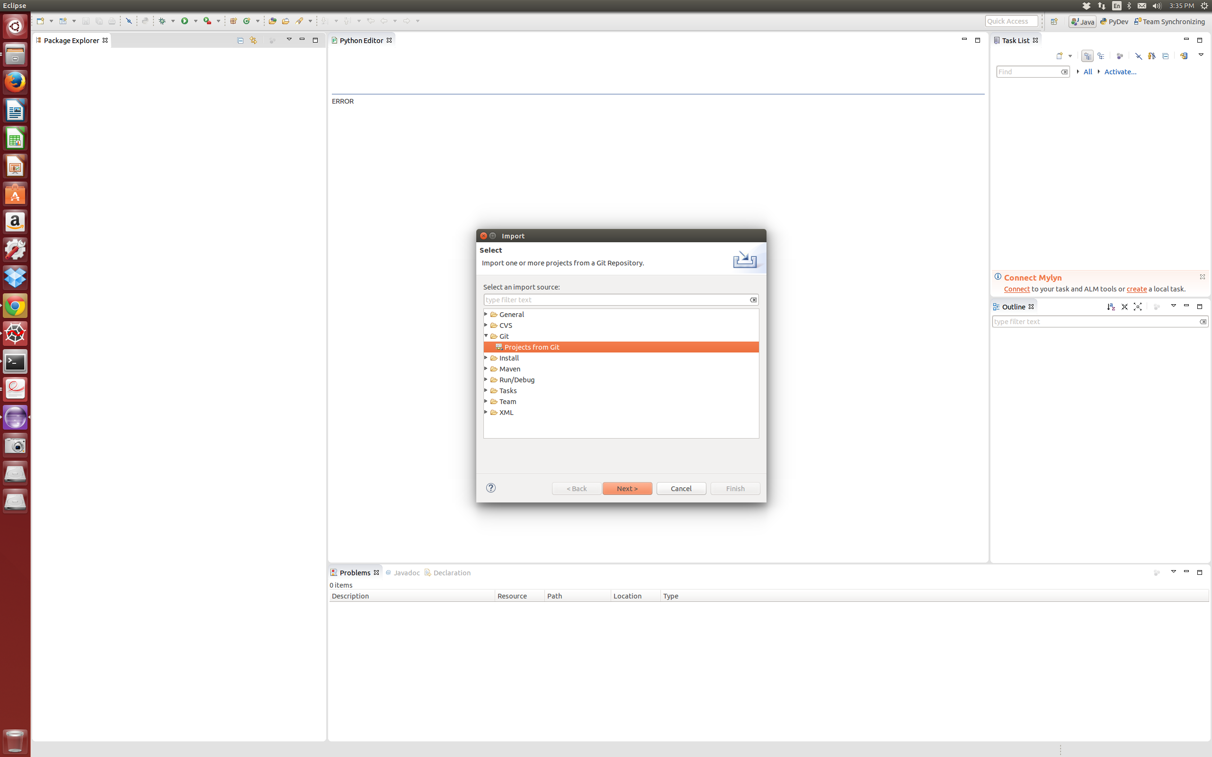

- Change branch of pysb
eclipse → right click on pysb folder → Team → switch to → dev
- Adding path
eclipse → window → preferences → quick auto config → new folder → (find the path) → apply → ok
- Add consule
eclipse → Window → Show View → (click everything you want to add)
- Push the updated files to github
(right click on the folder) → Team → Synchronize workspace → (click files that you want to push) → (right click on that files) → commit

